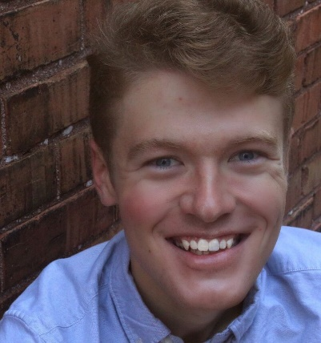

Caleb R. Curtis
(260) 492-3651 | curtiscr@umail.iu.edu
Height: 6’ 0”I Weight: 155 lbs. I Hair: Blonde I Eyes: Blue I Voice: Baritenor

ACTING
Educational Theatre
10 out of 12 (4/2018) Paul/ Carstairs Studio Theatre Corinne Florentino
Machinal (2/2018) Doctor/Judge/AC IU Theatre James Nelson
Heathers: The Musical Kurt's Dad Studio Theatre Joshua Robinson
Peter and the Starcatcher Smee IU Theatre Murray McGibbon, Ray Feldman
Prospect Hill A New Play Voice IU Theatre Ansley Valentine, written by Bruce Walsh
COCK F Studio Theatre Kevin Renn
King Lear OP Production King of France IU Theatre Murray McGibbon
Noises Off Phillip/Frederick IU Theatre Murray McGibbon
Humble Boy Felix Humble Studio Theatre Matthew Murray
Lieutenant of Inishmore Donny IU University Players Nick Pappas
Flowers for Algernon Charlie Gordon Northrop High School Tim Miller
Community Theatre
RENT Mark Cohen FWSMT Kirby Volz
Hairspray Corny Collins FWSMT Kirby Volz
Dreams and Nightmares Various FWSMT Kia Miller
Film
Rock, Paper, Politics? Politician IUCFF Ian Martin
Readings
Jungle Juice A New Play Riley Catalyst Project Kevin Renn
TRAINING
BA Theatre and Drama w/ Minor in Media and Advertising Indiana University class of 2019
Indiana University: Voice (Lesley Friend, Christopher Handley) Advanced Scene Study (Katie Horwitz), Realism (Murray McGibbon), Shakespeare (Murray McGibbon), Stage Movement (Leraldo Anzaldua), Jazz Dance (Rachel Newborough), Musical Theatre Workshop (George Pinney)
Interlochen Camp of the Arts: Acting Technique (Anne Cooper), Theatre Topics and Laban Technique (Jeff Nauman)
HONORS
3rd in the state in Dramatic Interpretation, IHSFA 2015
Best Actor in Thespian Troupe 7536, National Thespian Society 2014
National Semi-Finalist in Storytelling, National Forensics League 2014
3 time national tournament qualifier in Dramatic Interpretation, National Forensics League 2012-2014
SPECIAL SKILLS
Shakespeare Original Pronunciation dialect, British Dialect, Cockney Dialect, Southern Dialect, Roller Coaster Enthusiast, First Aid certified, Indiana Driver's License, Good w/ Kids and dogs!

