Diamond Burdine
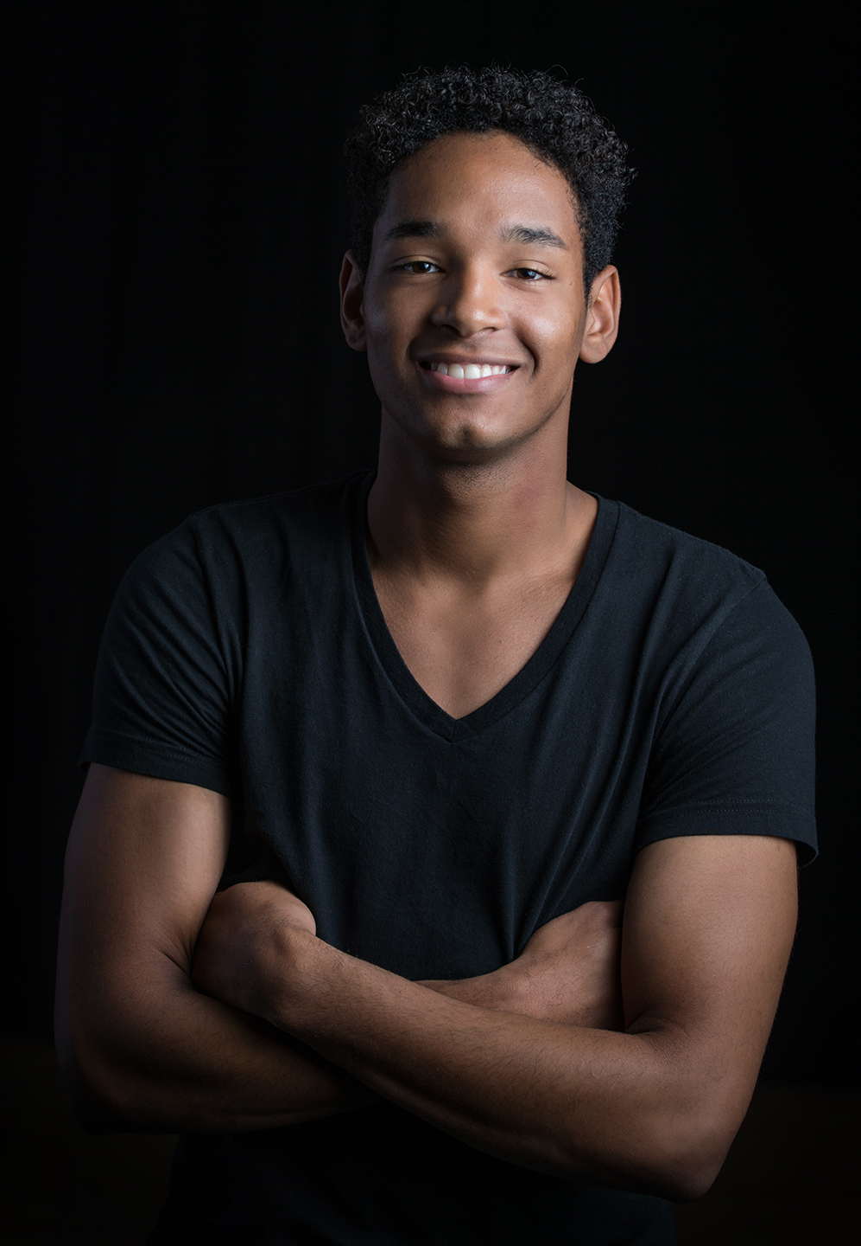
Email: Burdinediamond@gmail.com
1440 N. Dunn St. Height: 5’10”
Bloomington, IN 47408 Weight: 160
    - Age: 21

Performances:
- “BLUSH” Stephanie Nugent- IU Contemporary dance
- “Obscured Galaxies: Hot dust” Liz Shea- IU Contemporary Dance
- “D-man in the waters” Bill T. Jones- IU contemporary dance program
- “Spill” Gallim- IU contemporary dance program
- “Jam in A Canopy” Nya McCarthy - IU contemporary dance program
- Americas Got Talent (AGT) - Executive Round and Interview
- Six Flags/ Great America- Dance Fest
- Nationals Freestyle Face-Off Runner-Up - Tremaine Dance Nationals, Judged by Phi Nguyen( JBWKZ), and Twitch, Orlando, FL
- Spencer Kane Tour – Back-up Dancer
- Boom Crack! Dance Company Showcase, Chicago, IL
Training/Experience:
(2015-) Indiana University contemporary dance major- Bloomington, IN
(2010-2015) – Concord Dance Program -Elkhart, IN

- Studied Ballet, Modern, Jazz, Lyrical, and Hip-Hop dance
- Studied with Trae Turner (Boom Crack! Dance Co), Mari Jo Irbe (River North Dance Co), Stephanie Pairitz, Darci Freeman, Heather Hoffman, Roman Vasquez (LA), Marcus Sheilds (SYTYCD)
- Tremaine performance company (2010-2017)
- Tony Bellissimo - (SYTYCD), Rhianna, Chris Brown, “Step Up Revolution,” and “Step Up All In”
- Marty Dew “You Got Served”
- Jeff Amsden
- Keri LaGrand
- Derrick Schrader

